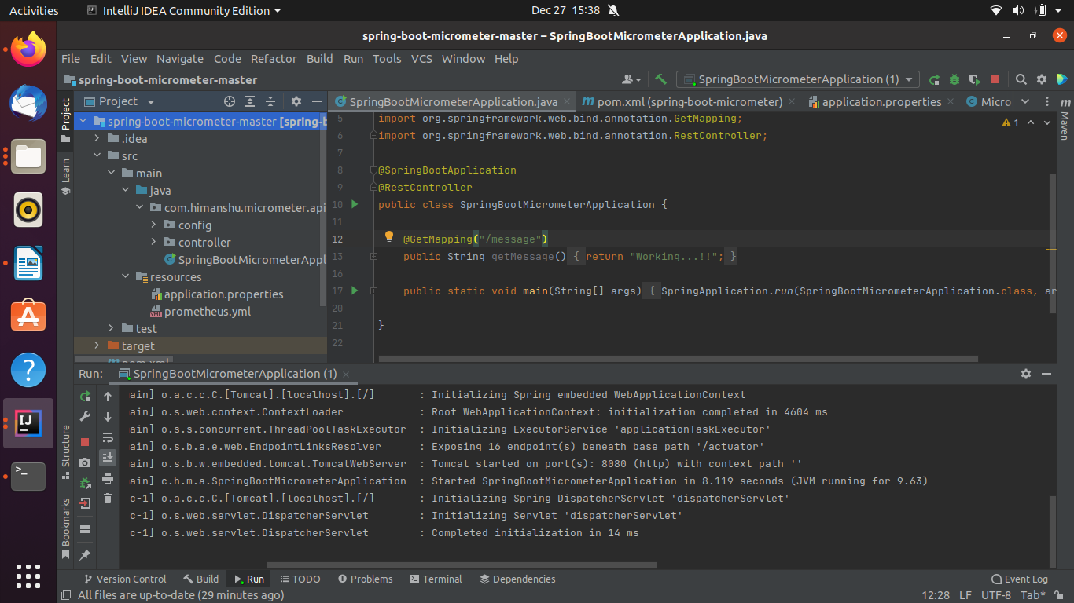  
  
  
Actuator end point  
  
http://localhost:8080/actuator

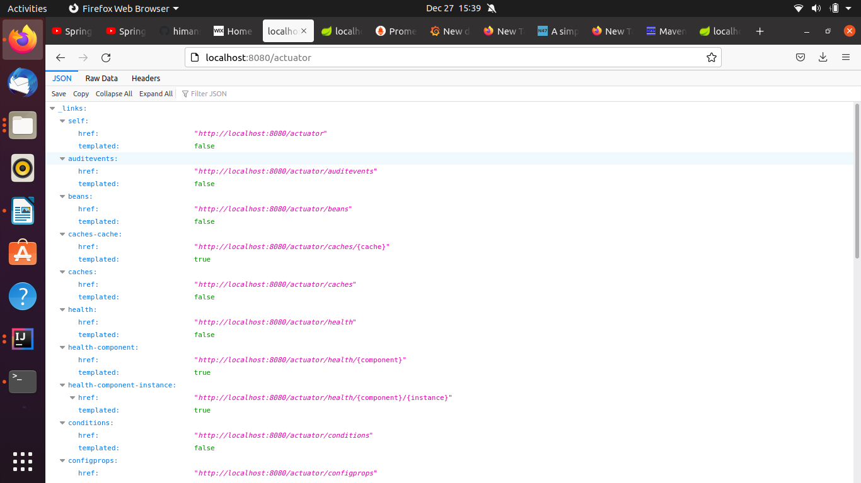  
Pull Prometheus Docker Image

docker pull prom/prometheus

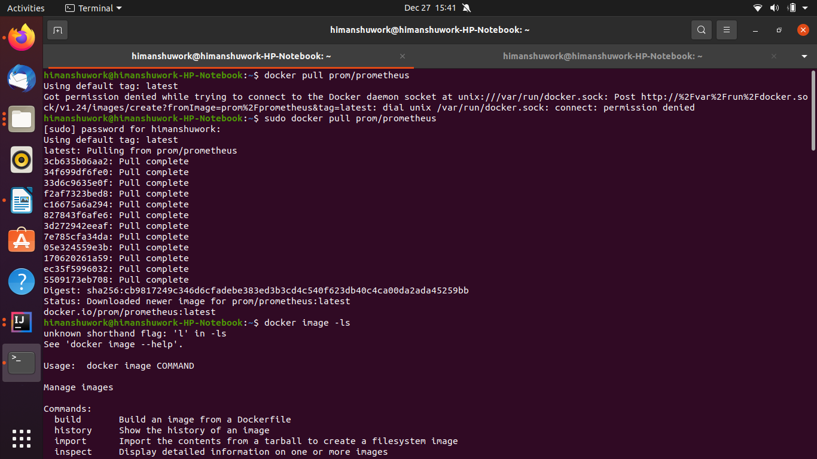  
  
Starting the prometheus service  
  
sudo docker run -p 9090:9090 -v /home/himanshuwork/Downloads/spring-boot-micrometer-master/src/main/resources/prometheus.yml prom/prometheus  
  
prometheus.yml is the file path present in your IDE(intelliJ)

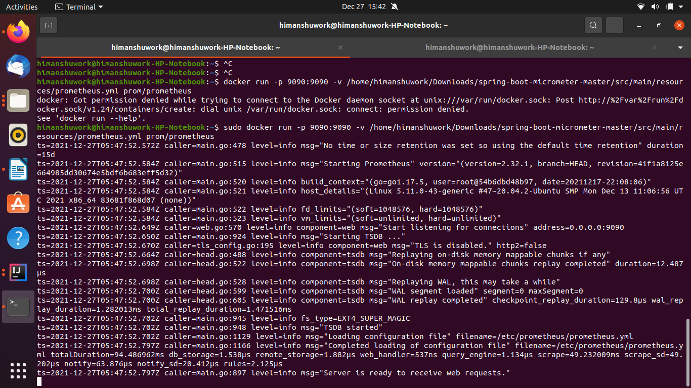

Verify Prometheus UI   
<http://192.168.0.107:9090/graph> (replace the Ip address with your IP)  
  
Pulling the grafana image and starting the grafana

sudo docker pull grafana/grafana

sudo docker run -d --name=grafana -p 3000:3000 grafana/grafana

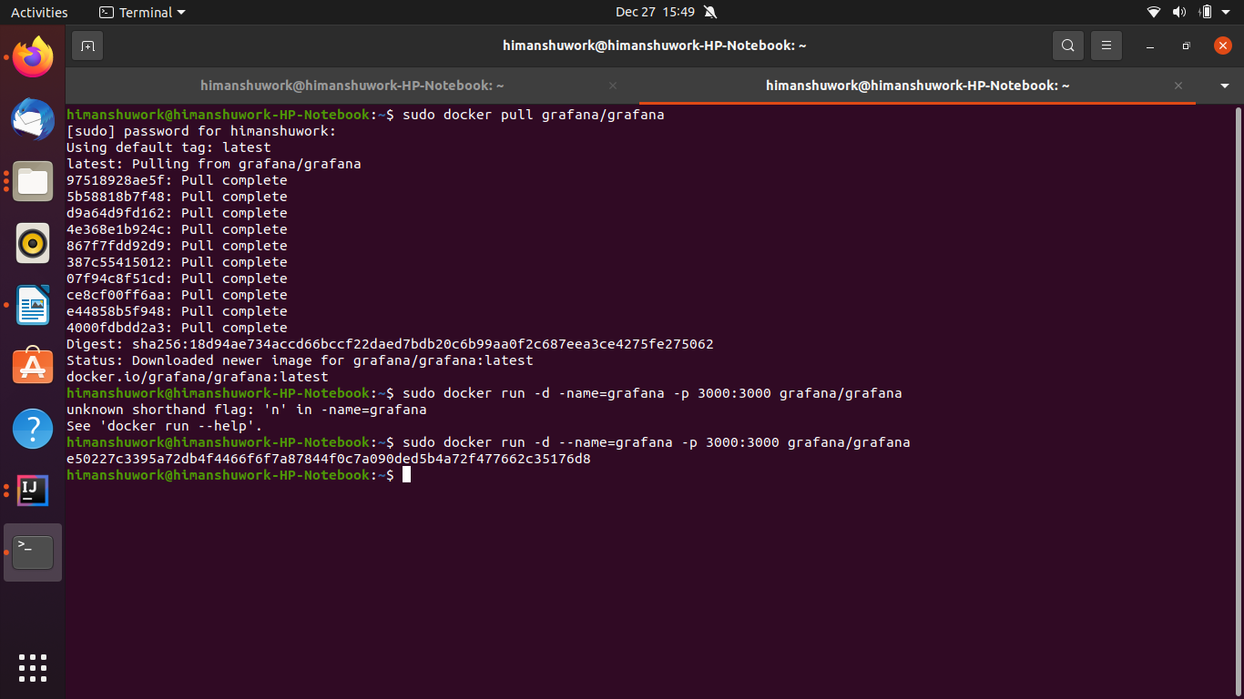  
once Prometheus and grafana is started .  
You can monitor any of the end point service

ex:

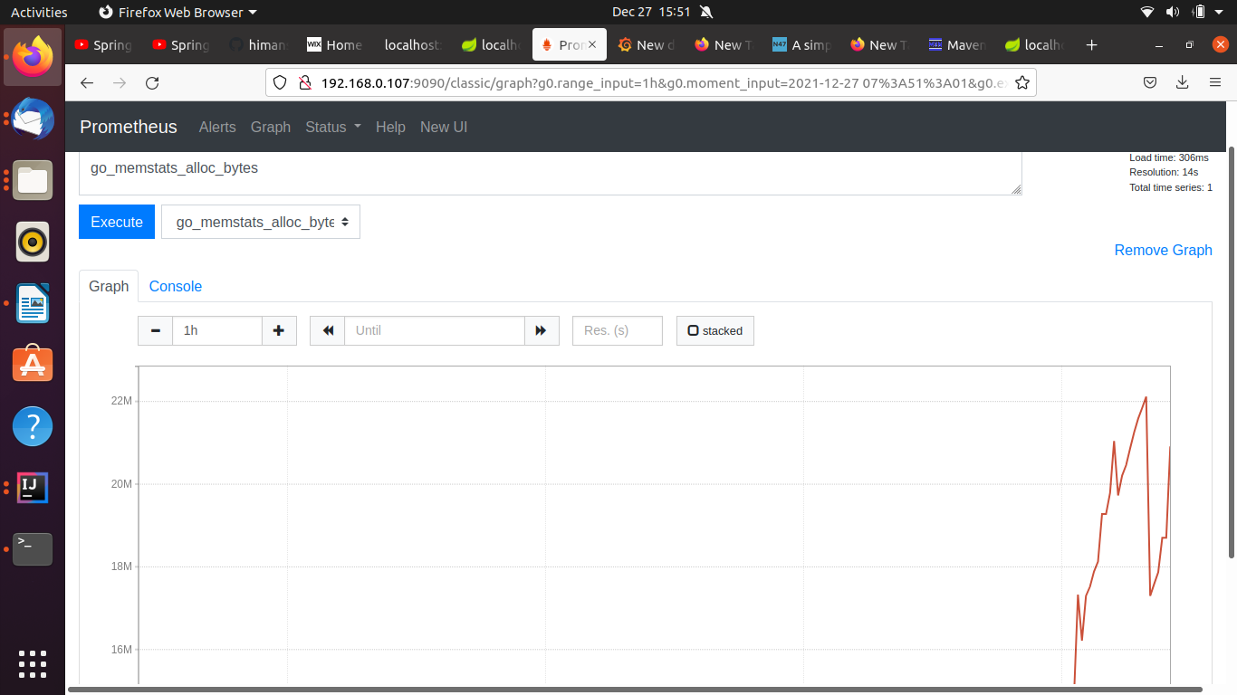  
  
Graph in Grafana UI

